Q 1) Creating and Renaming Files/Directories
Solution: Creating a directory named ‘folder-1’ using command line ‘mkdir’. Mkdir stands for make directory.
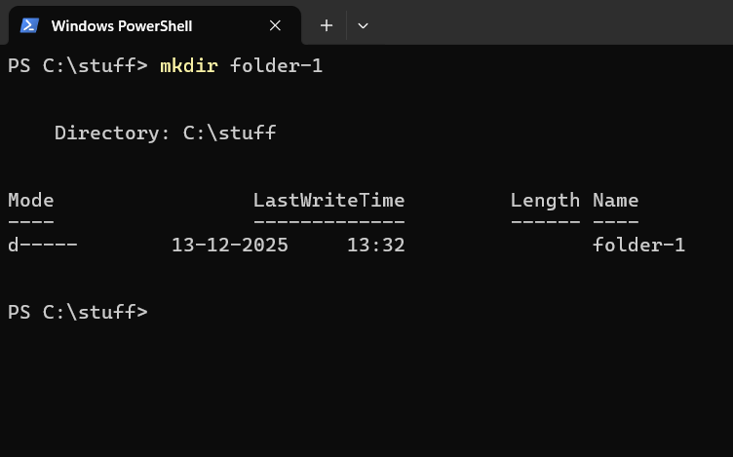
Renamed it using command ‘mv’ also help to move file/directory.
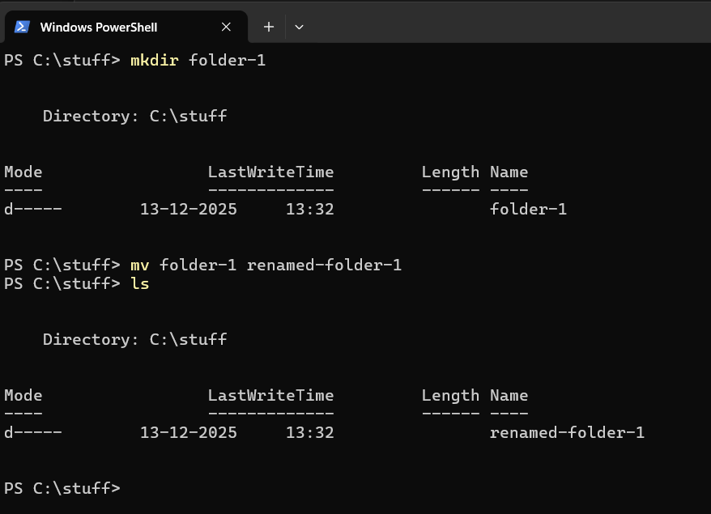

Q2) Viewing File Contents
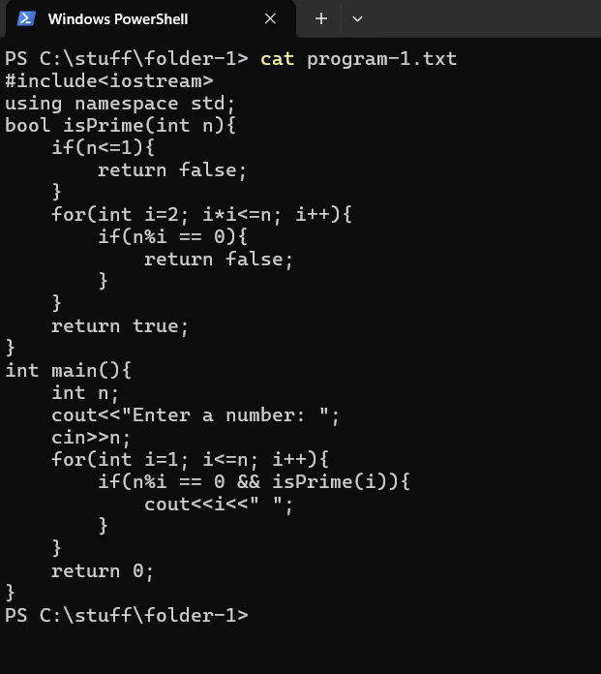
In the above screenshot, ‘cat’ command is used to display the content of the file.

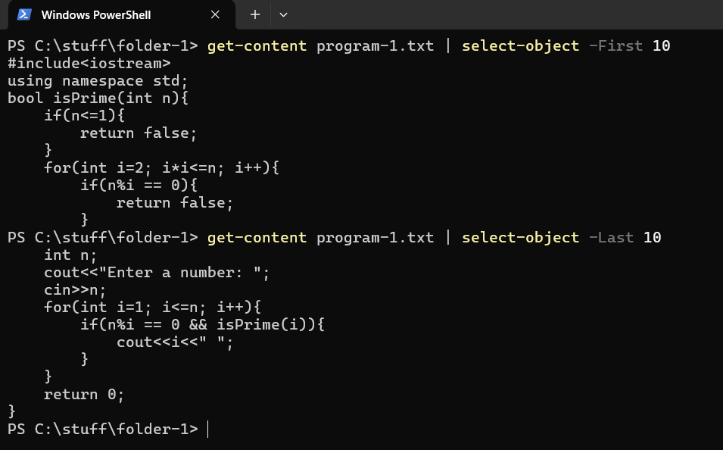
Above screenshot shows how to fetch specific number of lines of content. From stating as well as ending. First and last 10 line of a ‘.txt’ files content is shows on terminal.
Q 3) Searching for Patterns
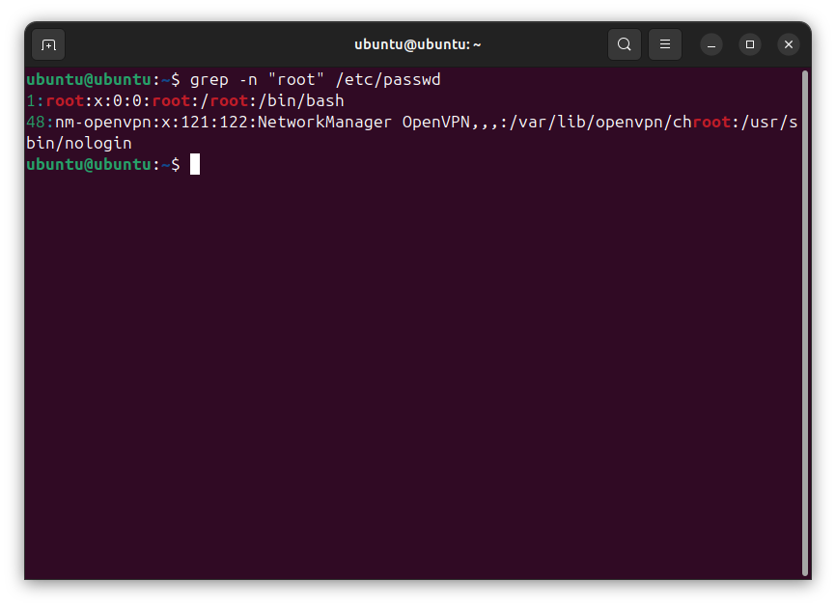
“grep” this command help to find words in a file, its helpful if you want to locate data and its location in a file.

Q4) Zipping and Unzipping
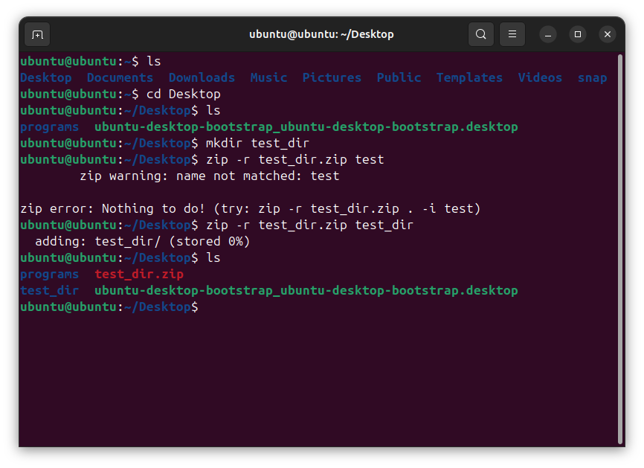
This command helps to zip and unzip the file.
Q5) wget = this command help to download files from internet 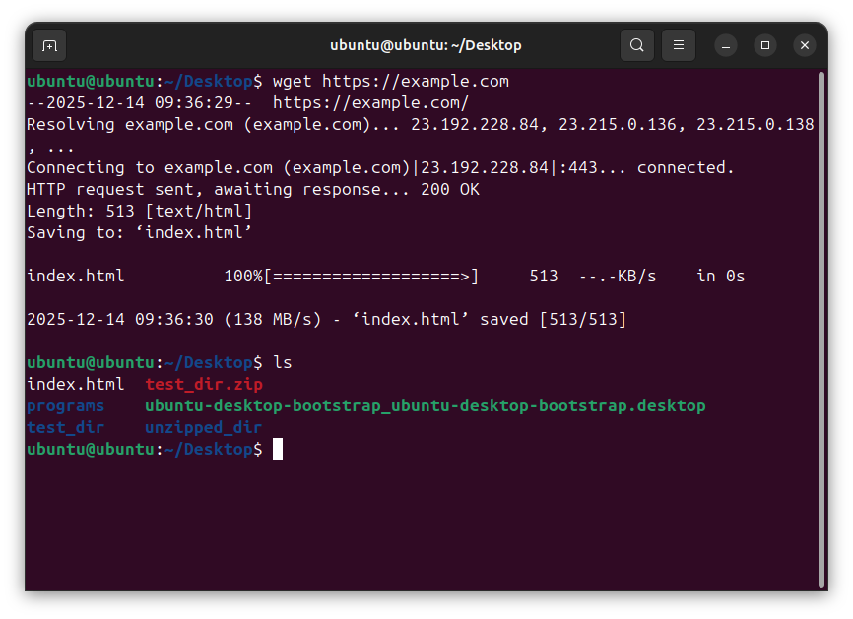

Q 6) Changing Permissions
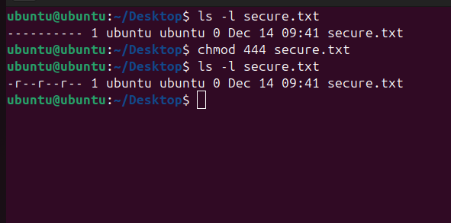
“ls -ls filename” this command help to view given permission to a file.
“Chmod 444 filename” help to give permission of reading and “chmod 777 filename” give all the permission. Like read, write, execute.
Q 7 ) Working with Environment Variables
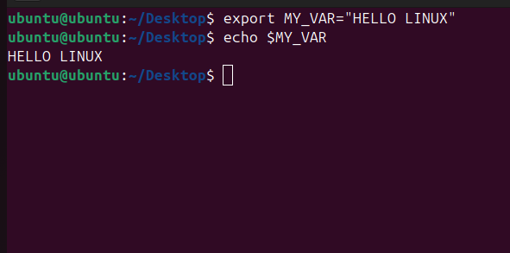
This “export” command use to create variable in the current terminal.

